**Screenshot Collaborator**

**A java Swing based utility tool to capture and export screenshots**

**Developed By: Arpit K Tiwari**

**How to use Screenshot collaborator –**

* Double click the jar file to run the application.
* Initial Screen –
  + Allows you to select the base directory for screenshot to get saved.
  + Navigate to a directory of your choice and click open to select it as a base directory.
  + On clicking “Cancel” or “Close”, default base directory **“C:/Screenshots”** will get selected.

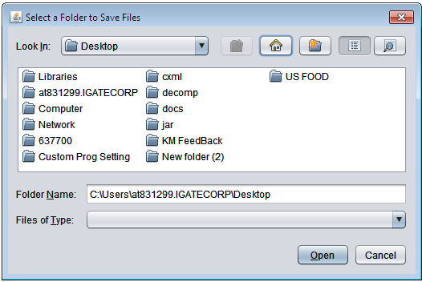

* Application Home Page-

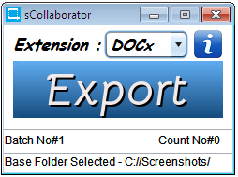

Details of the UI –

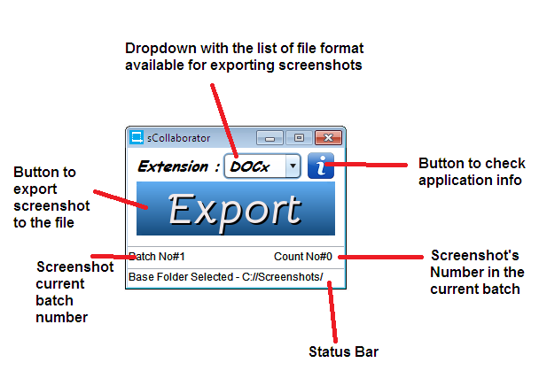

* To see information related to the application Click the **“i”** button –

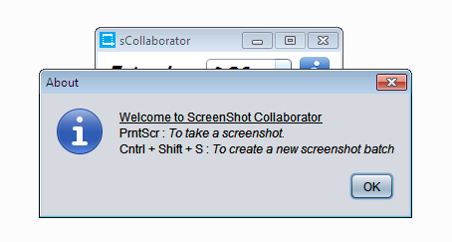

* To take a screen shot press **“Print Scrn”.** Thefile will get saved as mentioned in the image below. The file name of the generated screen shot will be of **“BATCH_<currentSequence>_<yyyMMddhhmmss>.JPG”** format.

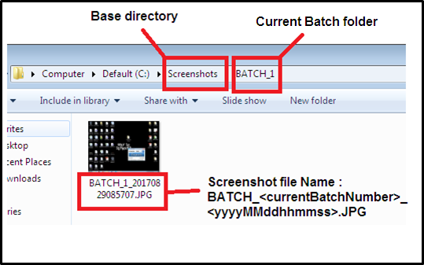

* The current screenshot count will reflect in the application screen for reference purpose.

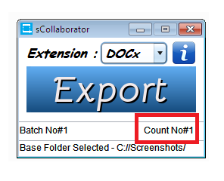

* To create a separate batch of screenshots, Press **“Cntrl + Shift + S”.** Same will be reflected on the application screen.

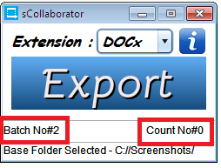

* To export the screenshots – Select the file type from the drop down and click export.

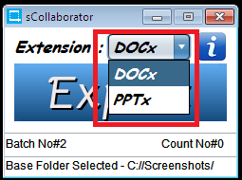

* Appropriate message will get displayed on the screen.

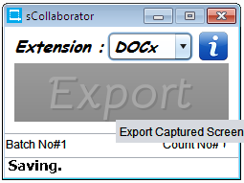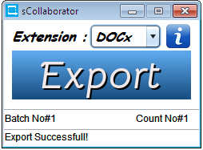

* Exported file will be saved in the BATCH Folder itself. The file name will be of **“ScreenShots-<yyyyMMddhhmmss>.<fileExtension>”** format.

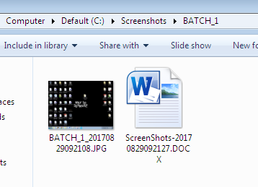

* Attached below the sample generate from the application.

Screenshot : 

Exported word file : 

Export PPT file : 